**Developing a Chatbot**

|  |  |
| --- | --- |
| Team ID | PNT2022TMID23716 |
| Project Name | Smart Fashion Recommender Application |

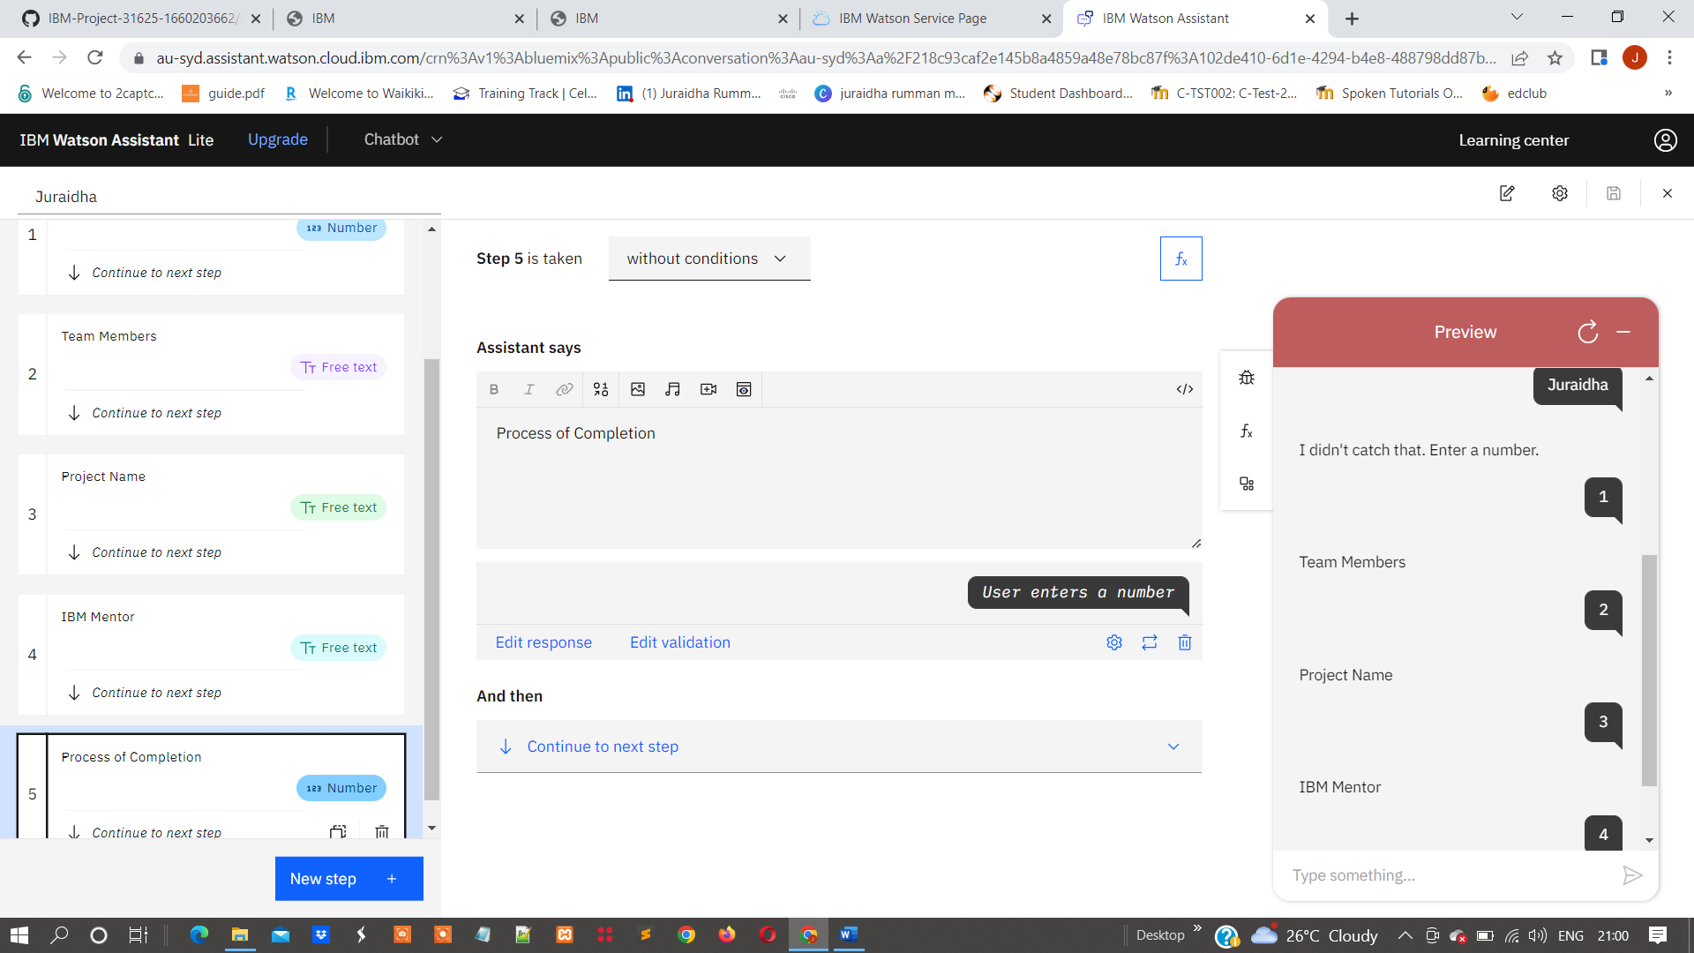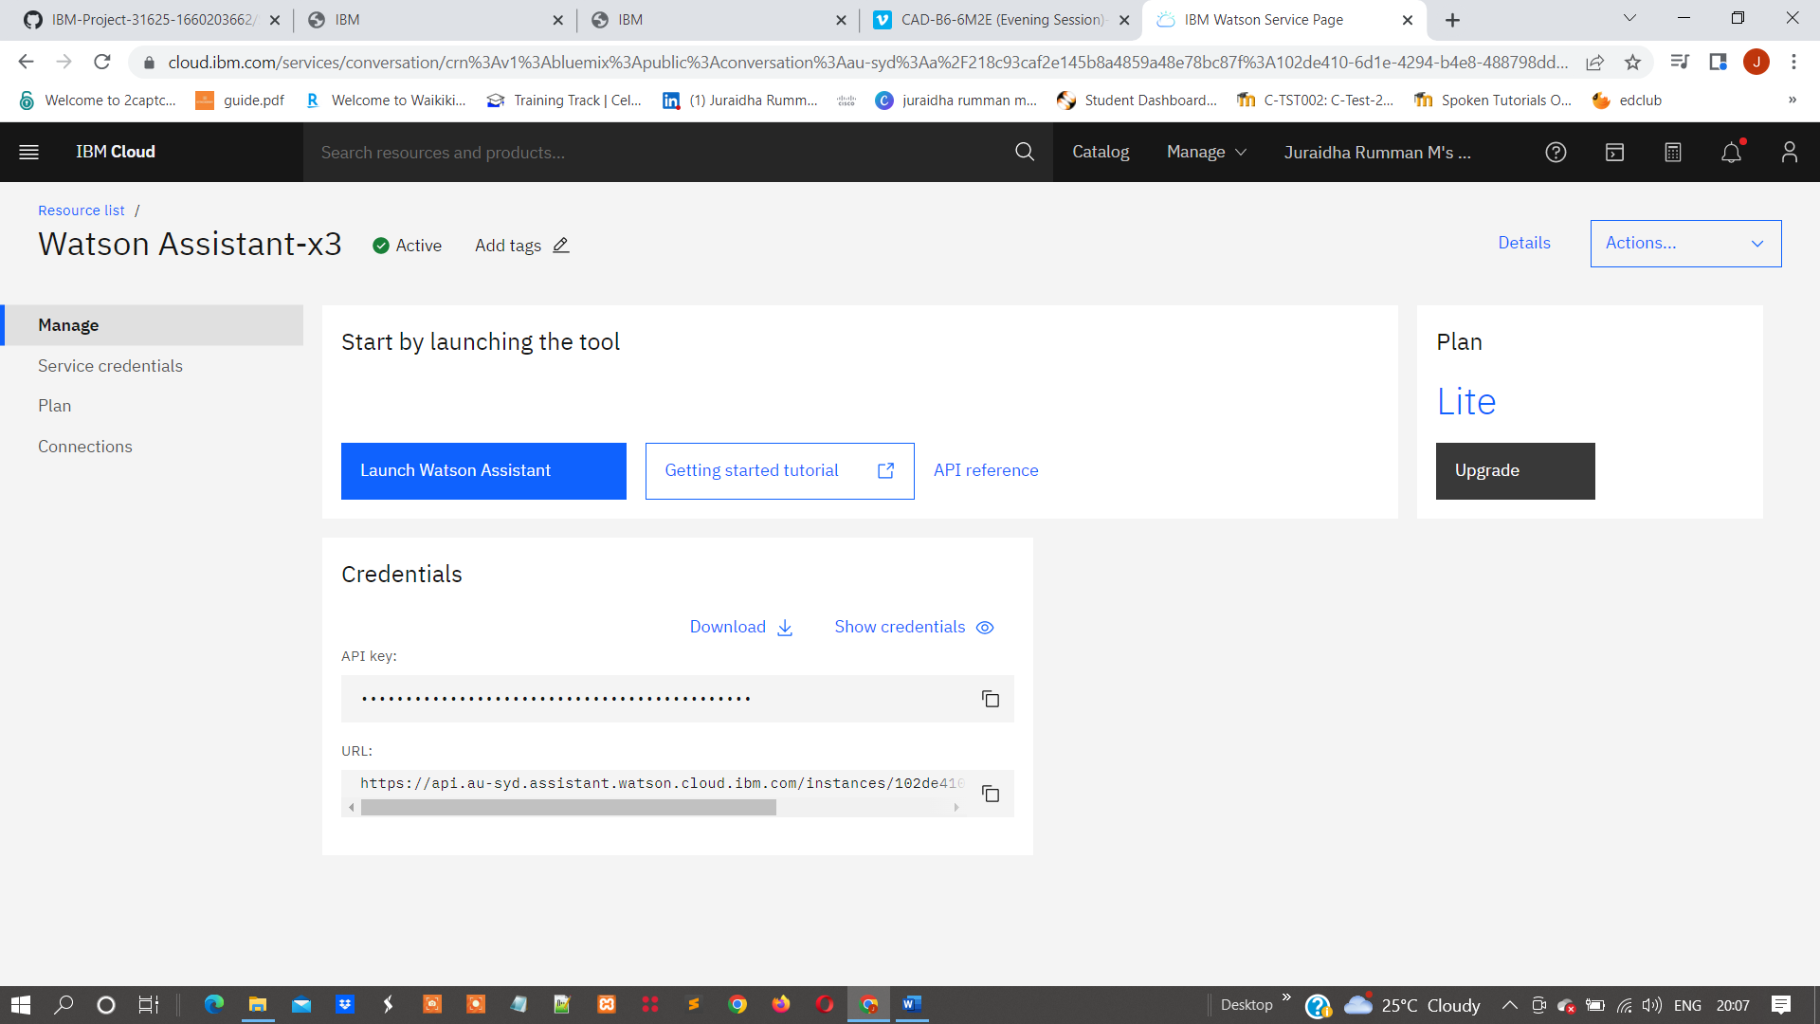

Step-1: Log in to Watson Assistant

Step-2:Create new actions

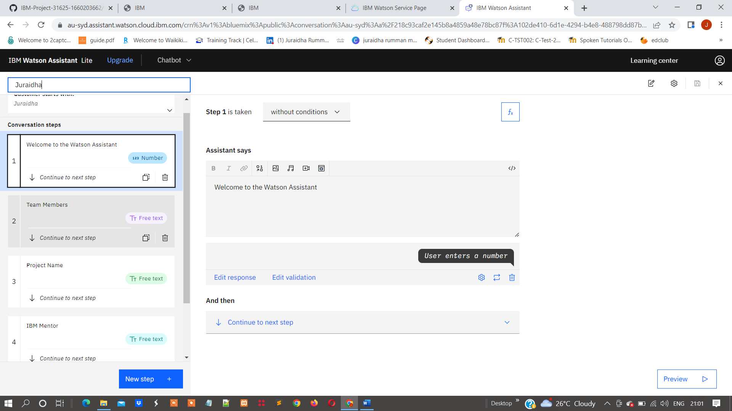

Step-3: Check the actions by using preview

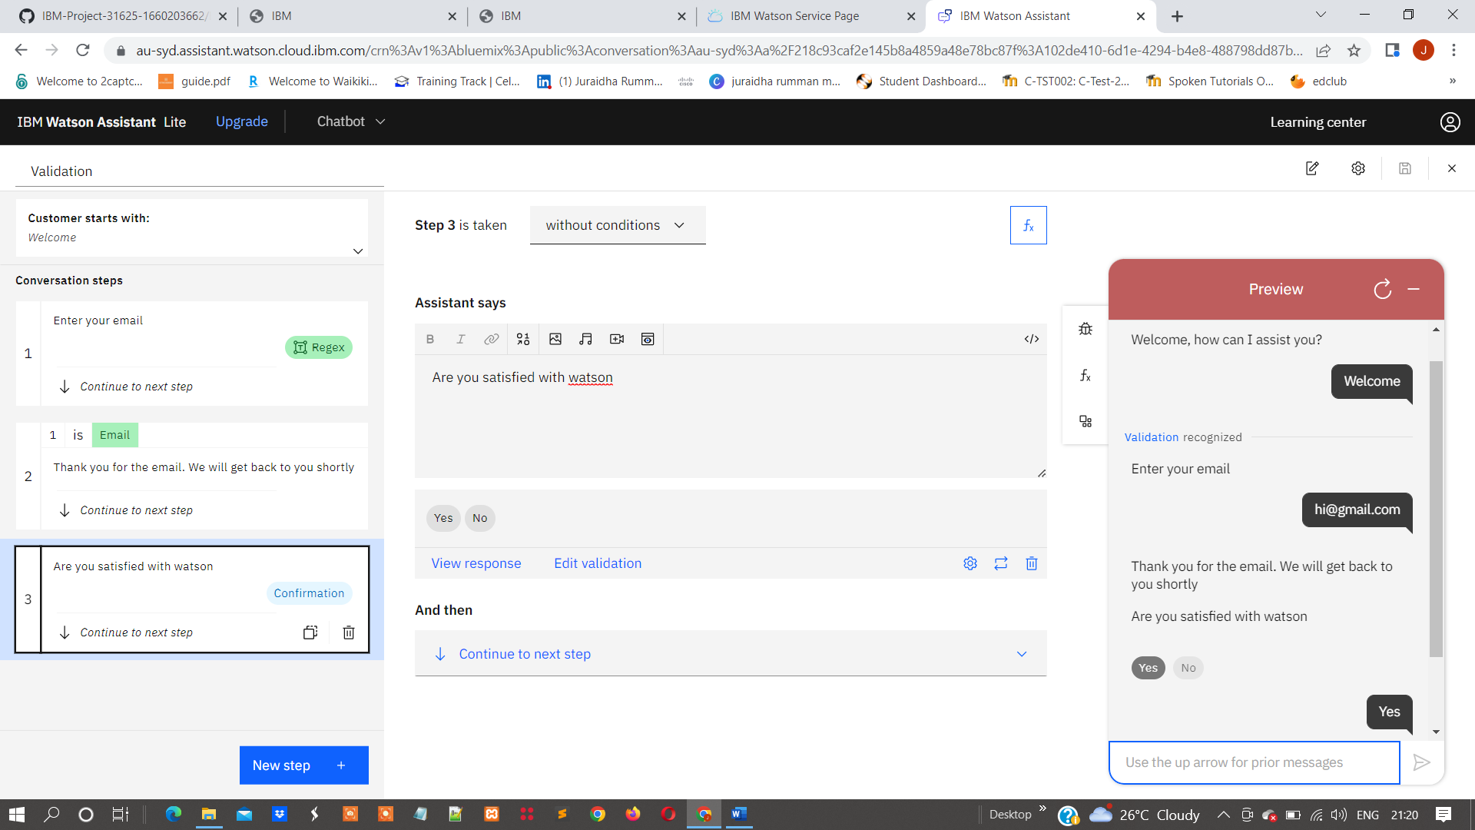

Step – 4: Publish the actions and validation

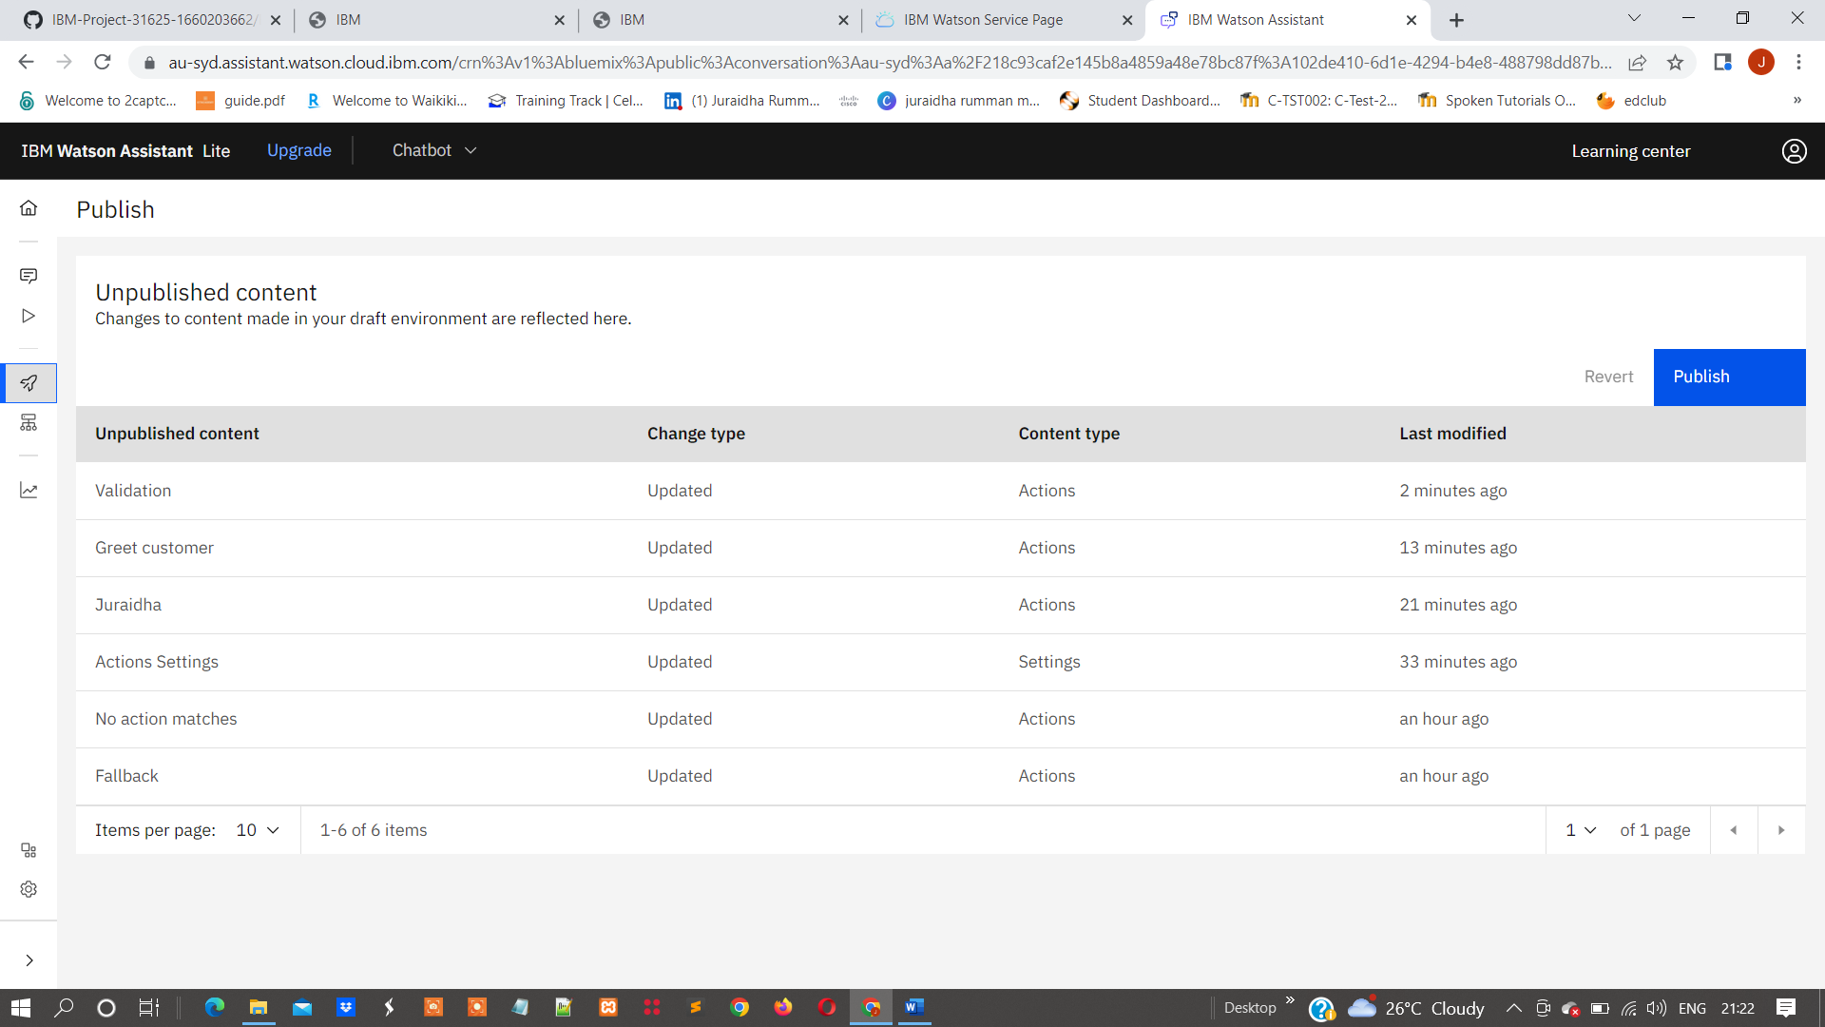

Step-5: Run the Embedded code in html format

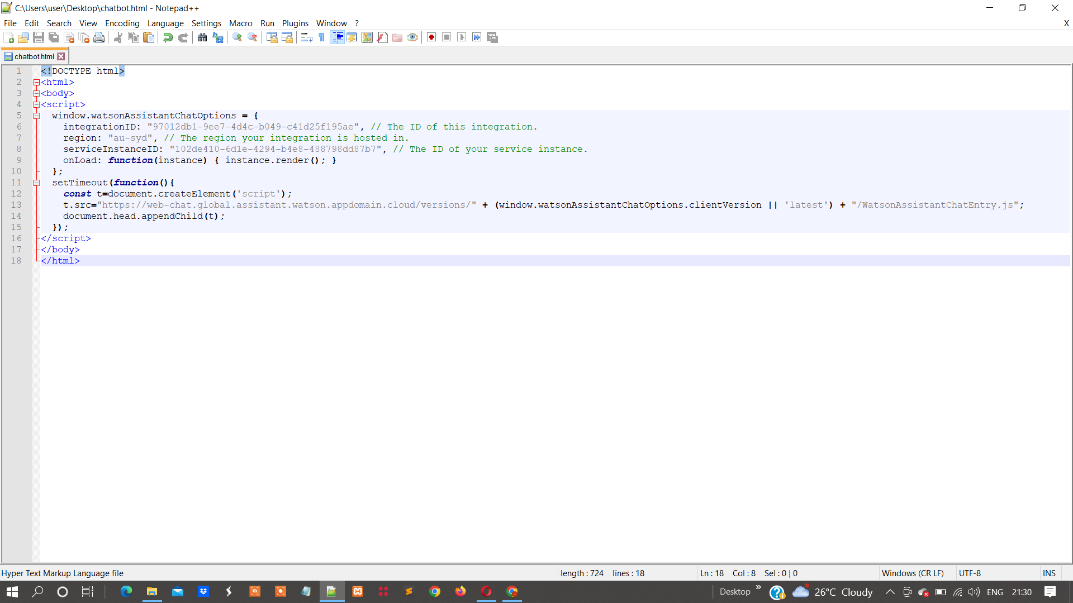

**Result**

Step-6: At webchat chat with the actions we published

